**BUYER’S GUIDE**

A **buyer's guide** is a piece of content designed to help customers make a buying decision by providing all the information they need in one place. 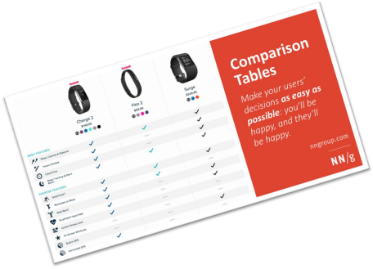

*Comparison between different products*

1 -

COVER PAGE

**Your buyer’s guide content**

5 - INTERVIEWS

3 - PRODUCTS

PRESENTATION



2 - TABLE OF CONTENT

4 - PRODUCTS COMPARAISON

**1 - COVER** PAGE

**2 – TABLE OF CONTENT**

✓ Header with your

ELECTRIC

ACOUSTIC

guide title

- MY BUYER GUIDE ON GUITARS - TABLE OF CONTENT

✓ Cover of your guide. ✓ Your name, class

THE FIGHT 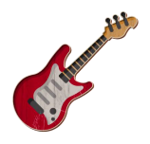RONAN OGOR – CLASS B

✓ The table of content shall be generated automatically

✓ Footer with page number

1 - Presentation of the products

1.1 - Acoustic

1.2 - Electric

2 - Which guitar should you buy ? 3 - Let s talk to musicians !

- PAGE 1 -

**3 –** PRODUCTS **PRESENTATION** ✓ This page shall have title 1 , title 2

✓ Use a nice layout between text and image to

present the 2 items you want to compare

✓ Your page shall also include some notes,

related to your researches

- MY BUYER GUIDE ON GUITARS -

**1 –Presentation of the products**

**1.1 The electric guitar** 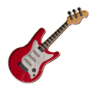

Electric guitars are easier to play. The

strings are lighter and far more

comfortable than acoustic guitars. One

key aspect which makes electric

guitars so appealing is that they are a

lot smaller than acoustic guitars, so it

does make learning more comfortable.

**1.2 The acoustic guitar**

Acoustic guitars are often considered

harder to learn. This is due to the

strings being heavier and the height of

the strings being higher than standard

electric guitars.

1 - The story of the guitar – 2021 – Rady Y

2 - Why acoustic are so good - 2021 – Rady Y

- PAGE 2 -

**4 –** PRODUCTS **COMPARAISON**

✓ The page shall **include a table** with

many criteria to compare the 2 items

✓ You need to evaluate each items regarding

your criteria

✓ **Find a way to present your evaluation in a**

**nice way (icons….)**

- MY BUYER GUIDE ON GUITARS -

**2 – Which guitar should you buy ?**

Electric guitars are easier to play. The strings are lighter and far more comfortable than acoustic guitars. One key aspect which makes electric guitars so appealing is that they are a lot smaller than acoustic guitars, so it does make learning more comfortable.

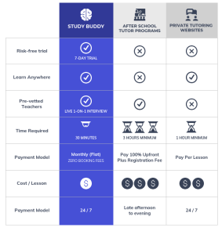

- PAGE 3 -

**4 –** PRODUCTS **INTERVIEW**

✓ Interview 2 students or teacher about

your product

✓ Find at least 2 question to task

✓ Find a good style to present well your

questions and the answers of your

interviewees

- MY BUYER GUIDE ON GUITARS -

**3 – Let s talk to musicians !**

**Acoustic guitar is my best** 

**friend in my life**

Why do you like to play acoustic ?

I like acoustic for my own compositions, as I put a lot of focus on

melody and wording. An acoustic guitar travels well, with no

supporting equipment

Why I you favorite song you like to play?

Il like playing the song called : Ronan is the best

Because Ronan is my favorite teacher

**Electric guitar is more fun!**

Why do you like to play acoustic ? 

I like acoustic for my own compositions, as I put a lot of focus on

melody and wording. An acoustic guitar travels well, with no 

supporting equipment

Why I you favorite song you like to play?

Il like playing the song called : Ronan is the best

Because Ronan is my favorite teacher

- PAGE 4-

MON

MAY 15

**Project timeline**

MON

MAY 22

✓ Choose the product to

compare

✓ Research about the products

and perform you interviews

✓ Design your guide ( font,

color , titles,

margin, table, columns, etc.…)

✓ Write the

guide

PRESENTATIONS

Evaluation**This is your evaluation of** 

**MS WORD**

|  |  |
| --- | --- |
| **MS WORD SKILLS** |  |
| Header and footer well defined | 5 |
| Same style used for the entire document | 10 |
| Table of content is automatically updated | 5 |
| Good usage of Title1, Title2 …. | 5 |
| Good layout between images and texts | 5 |
| Use of Foot notes | 5 |
| Good table layout to compare the products | 10 |
| Good usage of margins and spaces | 5 |
| **SOFT SKILLS** |  |
| Good graphic design *(alignments, color, font.)* | 10 |
| Creativity, imagination | 20 |
| Information is relevant | 20 |
| Good usage of ENGLISH (BONUS) | 10 |